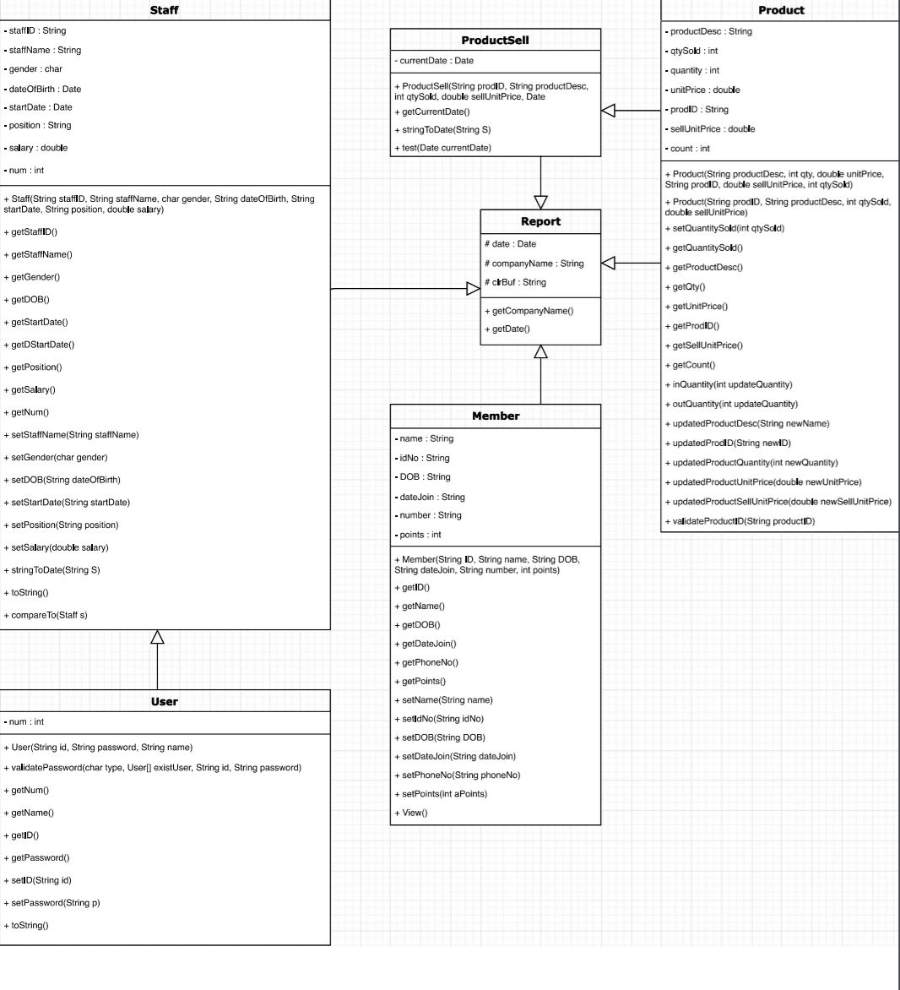**UML DIAGRAM**

**Screenshots of System**

**MAIN MENU ADMIN/MANAGER view**

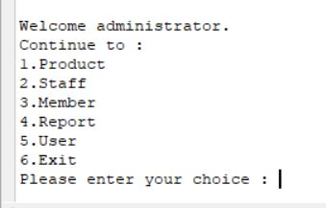

**MAIN MENU STAFF view**

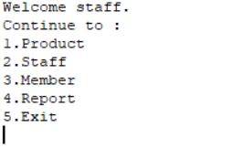

**Report module**

Each of the report will provide the arrangement on it such as arrange name/description from A to Z or Z to A. Then some of the report will have specific search report, report sort by working hours or quantity.

Admin/manager menu view

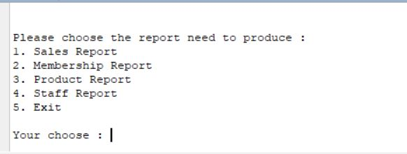

Staff menu view

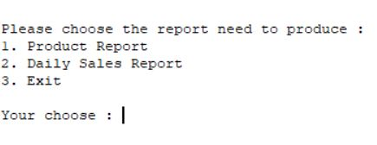

Sales Report type

-Daily

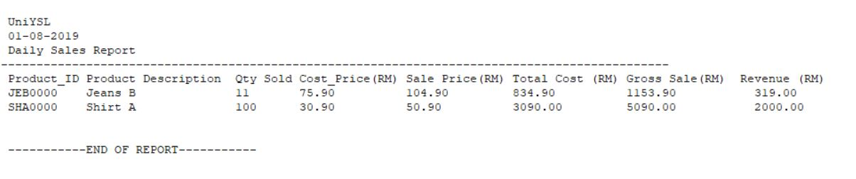

-Monthly

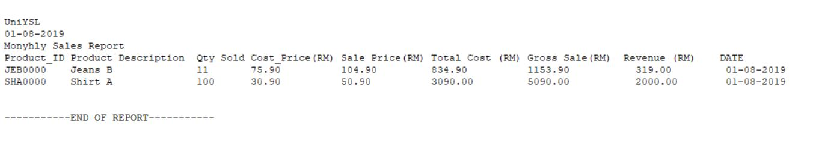

-Yearly

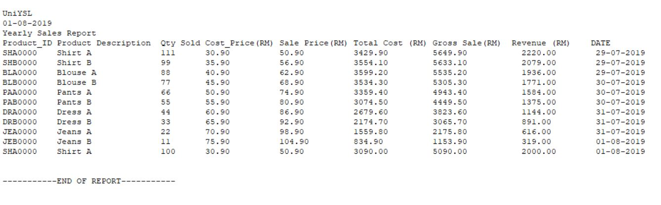

Membership Report

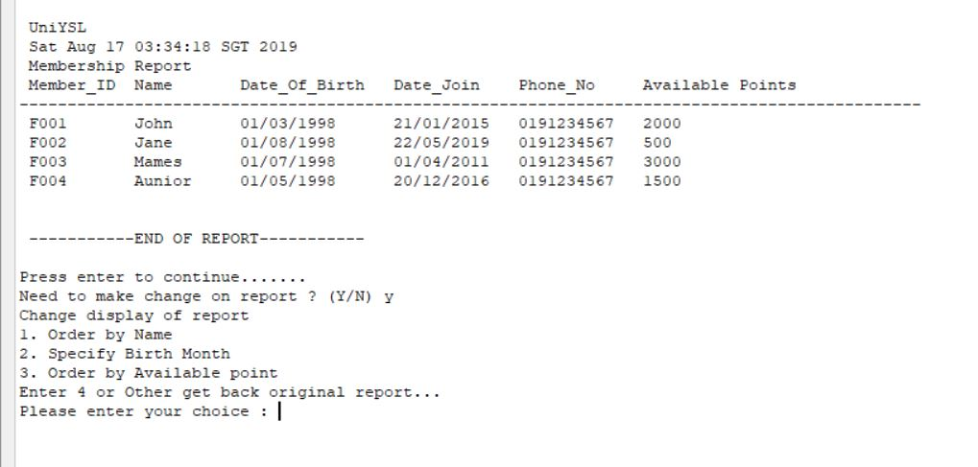

Staff Report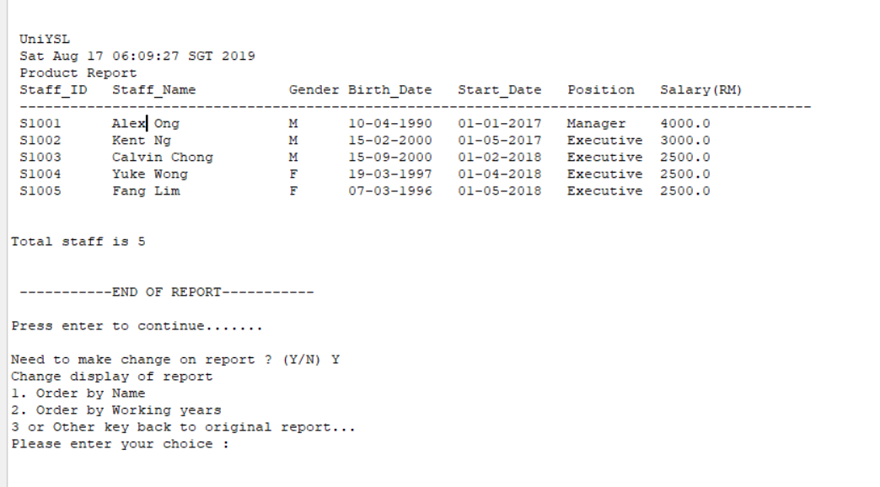

Product Report

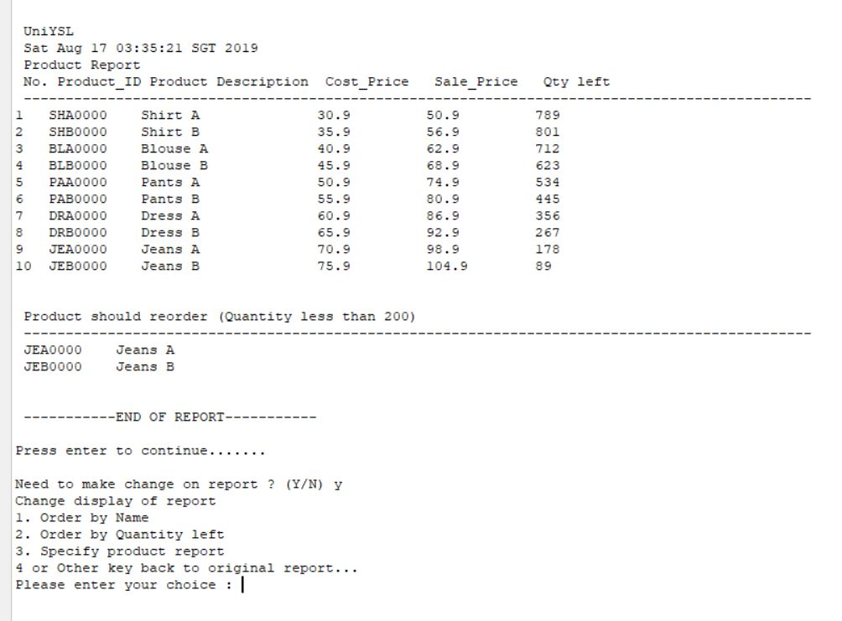

Example of specific report (Specific birth month Member)

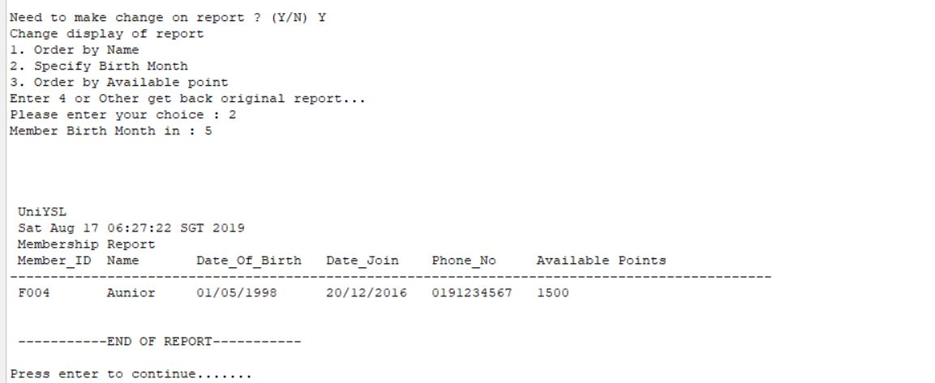

**USER MODULE**

Only admin /manager have authorization to control user

(Admin have highest power; manager only can control staff user account)

Normal staff account will start from ‘S’

Manager account will start from ‘M’

ONLY have one admin account which are start with ‘A’, consider as manager but that have full access in the system.

SIGN IN

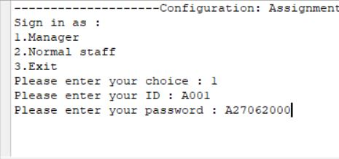

USER MENU

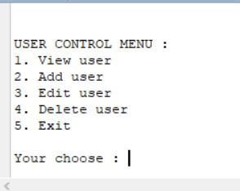

VIEW USER

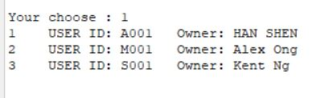

ADD USER

If add in a manager, System will request the Admin ID and Password, make sure the authorization of user will not out of standard

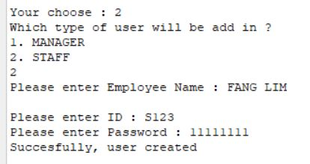

EDIT USER

Inside this admin user that ID and password cannot be changed, If want to edit manager account that will request Admin account to do it

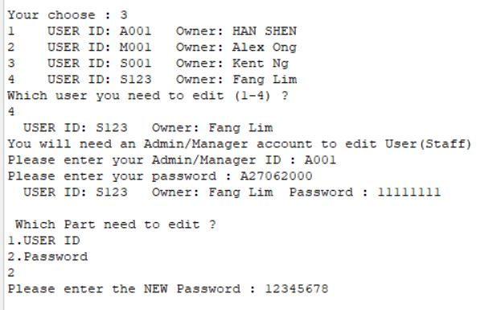

*If want to edit Manager account

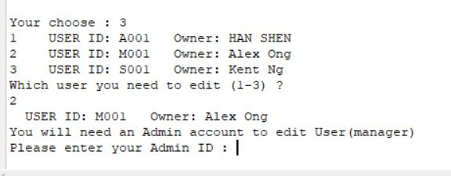

USE NEW PASSWORD LOGIN

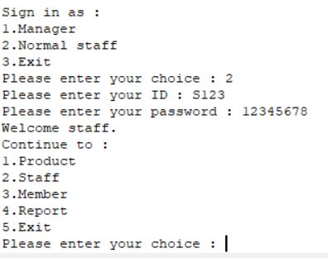

DELETE USER

If user deleted that will not available for login anymore.

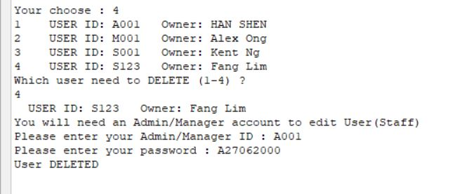

**MEMBER MODULE**

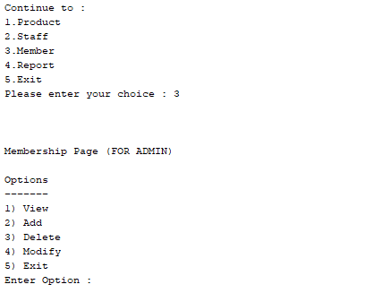Admin Menu, only can access though admin access

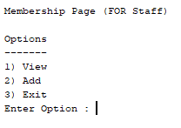Staff Menu, only can access by staff

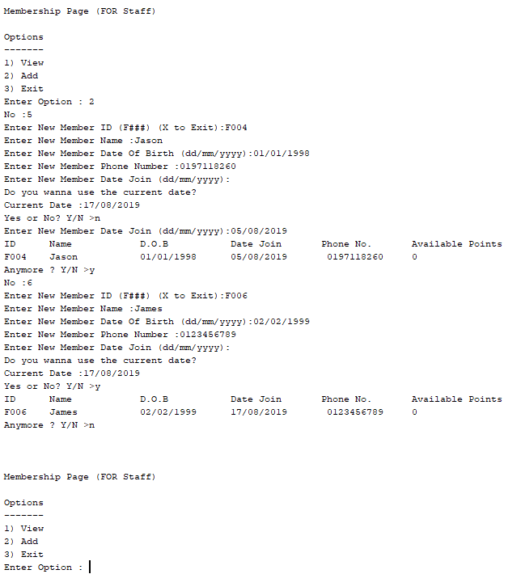

Add Member Process

Only can be access by admin and staff, as you can see from the picture above when user input ‘n’ they will have to manually input Member Date Join. When ‘y’ is input by the user the program will use the current date on the device. The program will ask the user if there is still more member to add they will need to either input ‘y’ to process to add more or input ‘n’ to go back to main menu.

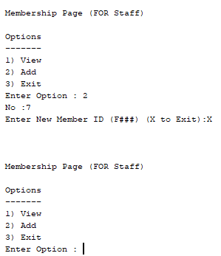

Add Member Process

Enter ‘X’ to exit from add member process

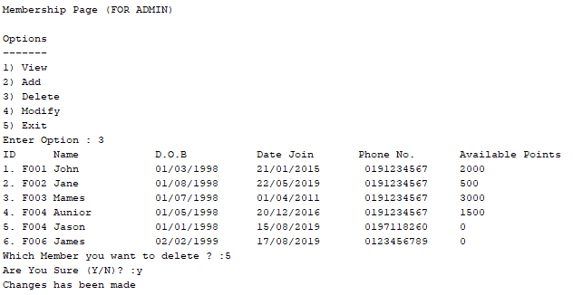

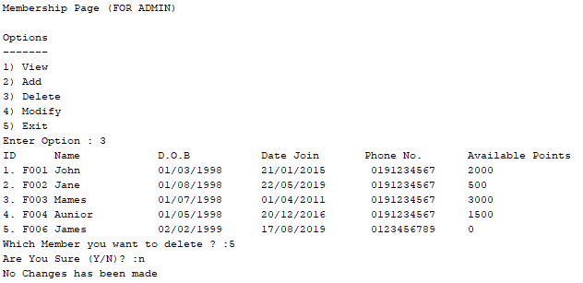

Delete Member Process

This process can only be access by an admin. When this process is selected the program will print out numbers besides each array, user will have to select which array that they want to delete. From there the program will ask the user to enter a number from the list. After entering the number, the program will ask the user for confirmation if they wan to delete it or not. If user input ‘y’ the program will remove that array, prompt to let user know the process has been made and exit the process. If user input ‘n’ the program will prompt to the user no changes is made and exit the process.

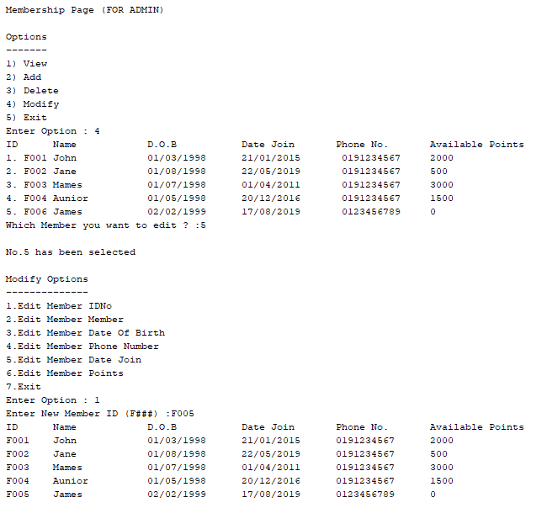

Modify Member Process

This process can only be done by an admin. When this process is selected the program will print out numbers beside each array, user will have to select the array which they want to modify. After entering the number, the program will prompt the user to choose what needed to be modified. From the picture above we can see the user choose to edit array No.5 and select to edit its IDNo then user will be prompt to enter the correction. After entering the correction, the program will prompt the user what changes has been made.

**Staff Module**

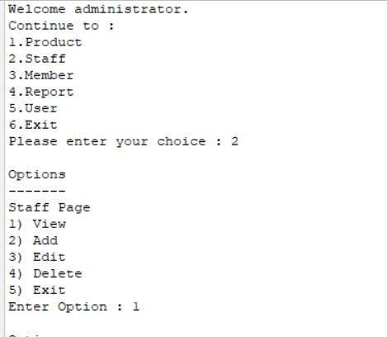

Admin Menu, only can access by admin.

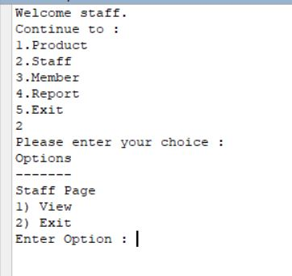

Staff Menu, only can access by normal staff.

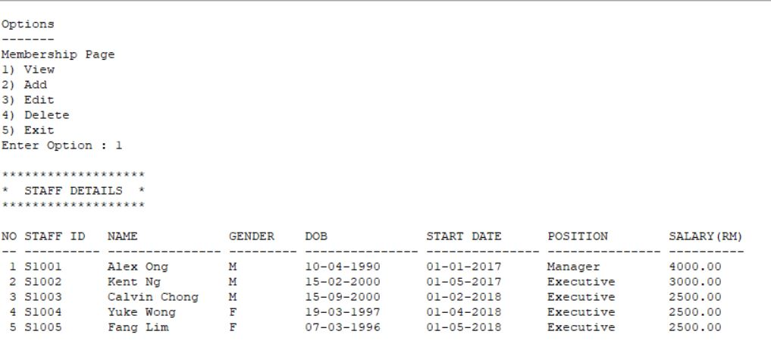

View staff process

Can be access by admin and staff, as you can see the user input No.1 and the program had showed all the staff detail.

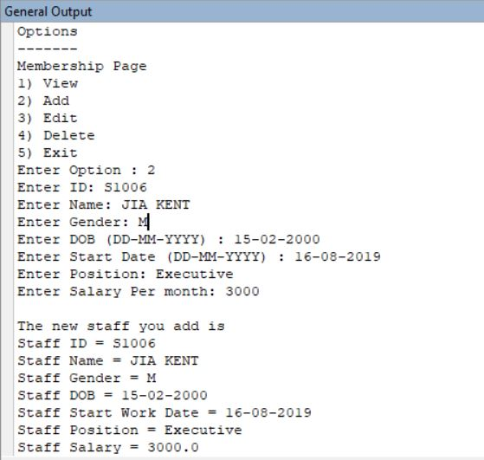

Add Staff Process

Only can be access by admin, as you can see from the picture above when user input all the staff detail, the data will add in to the STAFF. Then, we will display all the data that the user input.

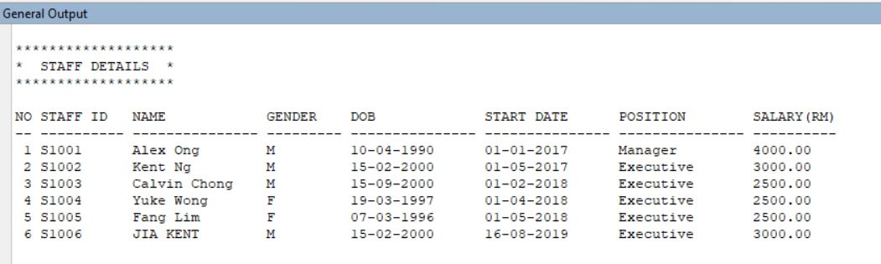

This is the result of the add process.

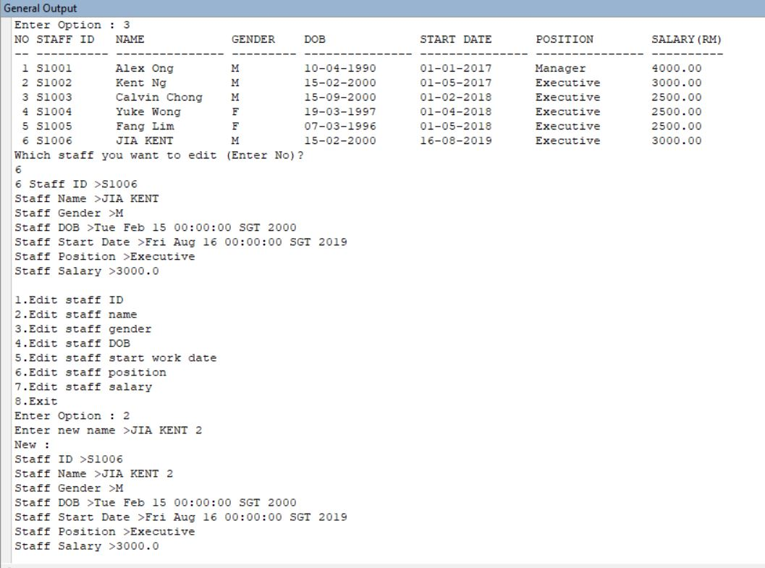

Edit Staff Process

This process can only be done by an admin. When this process is selected the program will print out all the staff detail with number, user can select which data want to edit. After entering the number, the program will prompt the user to choose what detail needed to be edited. From the picture above we can see the user choose to edit array No.2 and select to edit its name, then user will be prompt to enter the correction. After entering the correction, the program will prompt the user what changes has been made.

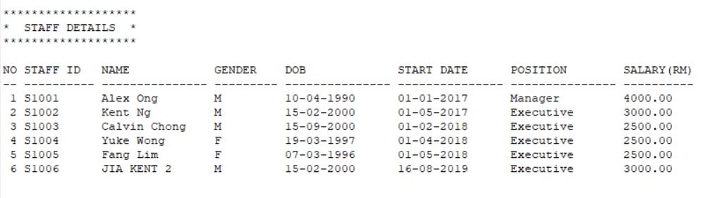

This is the result of the EDIT process.

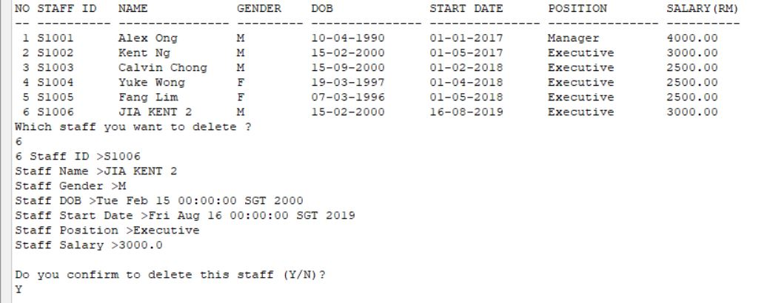

Delete Member Process

This process can only be access by an admin.When this process is selected the program will print out all the staff besides each array, user will have to select which array that they want to delete. From there the program will ask the user to enter a number from the list. After entering the number, the program will ask the user for confirmation if they want to delete it or not. If user input ‘y’ the program will remove that array, prompt to let user know the process has been made and exit the process. If user input ‘n’ the program will prompt to the user no changes is made and exit the process.

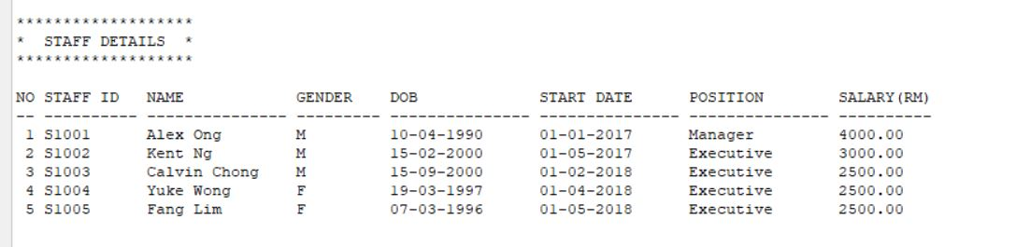

This is the result of the DELETE process.

**Product Module**

Before go through the product module, i want to brief about admin view and staff view of the product module. Admin can add, edit and delete the data of the product. Staff then can accept incoming goods, accept order and view the product detail.

Firstly, we login as admin. Then we want to add a new product. So by step, we choose option 1 which is add new product.

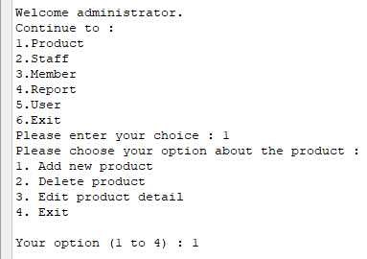

After that, as a admin, we need to enter the new product detail into the system. System will help to store into new data. After enter all the details, we choose to leave the add product function.

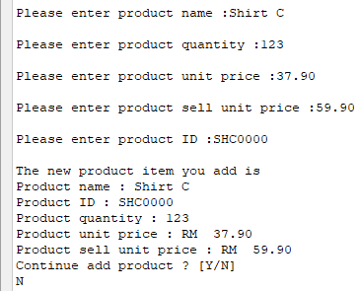

Continue on, now as a admin, if we suddenly want to remove one of the product. We can choose option 2 which is delete product. Then, system will show the menu to us about which product that we need to remove. Once we enter our option to the system, the system still need us to provide product ID of the chosen product for higher secure level. If the product ID was enter correctly, system will direct delete that product.

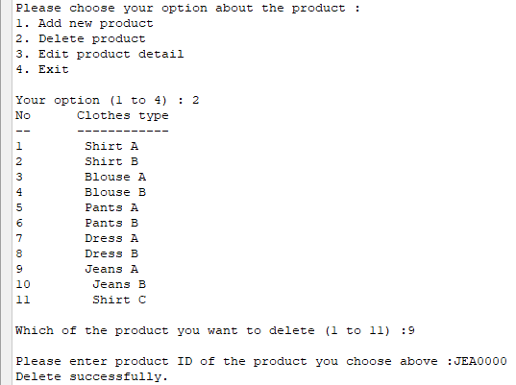

Next, we use the edit product function. This function can be use when inspector of the stock was find that the quantity of product doesn’t match with the system number, then the admin should use this function. Other than, just now the Jean A we delete is disappear from the menu already.

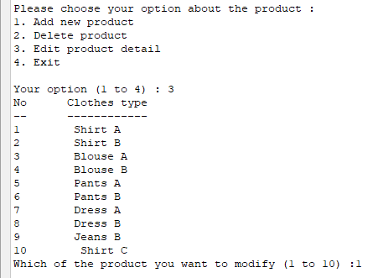

After than, same as delete function, we still need to provide the product ID to let the system know you are the real user for the system. Other than, system will show out the current detail of the product that the user choose. Then, if we follow the scenario above to update the quantity of the product. Finally, the system will show old data and new data to let the user confirm the changing of the data. So, that’s all for the admin view about the product.

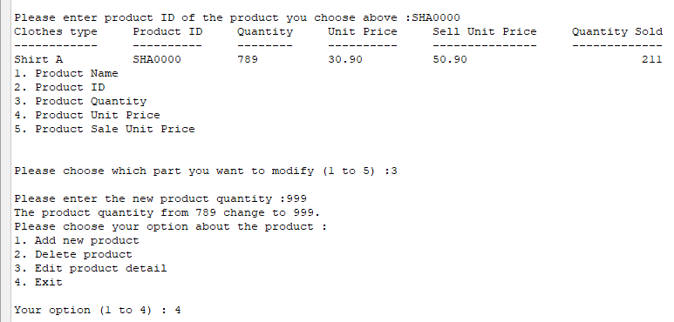

Now, let us restart the program, so the data go to the back.

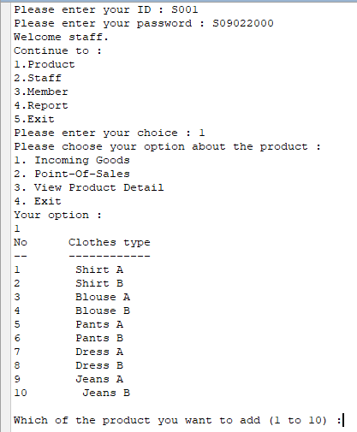

After we type in the quantity, product ID validation will check the user again. Next, as a view of a product module, i want to incoming good. And finally, the updated quantity will show out. By back to the staff product,i will view all of the product detail. The output result will show like picture below.

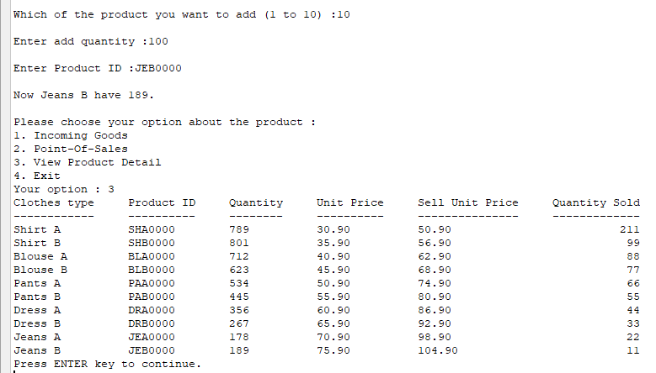

Next if a staff want to do accept order from customer, they can choose option 2 which is point of sale function. Assume that first customer buy two product, second customer buy one product, then end the transaction, the following picture will show as below.

